**11. ReactJS – HOL**

**Objectives**

* **Explain React events**

React events are just like HTML events (like onClick, onChange, onSubmit, etc.),  
but they use camelCase and work with functions.

Example:  
*function handleClick() {*

*alert("Button was clicked!");*

*}*

*function App() {*

*return <button onClick={handleClick}>Click Me</button>;*

*}*

* **Explain about event handlers**

An event handler is a function that runs when an event happens like a click, typing, mouse hover, etc.  
  
For example:  
In React, we write a function, and then pass it to an event:

*function handleClick() {*

*alert("Button clicked!");*

*}*

*<button onClick={handleClick}>Click Me</button>*

* **Define Synthetic event**

A Synthetic Event in React is a fake copy of the real browser event.

React uses it to make sure your code works the same in all browsers.

* **Identify React event naming convention**

i) Instead of lowercase like in HTML, React uses camelCase.  
  
Example:

|  |  |
| --- | --- |
| **HTML** | **React** |
| onclick | onClick |
| onchange | onChange |
| onsubmit | onSubmit |

ii) In React, pass the function name directly (no quotes or parentheses)

*function handleClick() {*

*alert("Button clicked!");*

*}*

*<button onClick={handleClick}>Click Me</button>*

**EXERCISE – 2:** Creation of an Event Example App

Step 1: Open **VS Code**

Step 2: Create a New React App

**npx create-react-app eventexamplesapp**

Step 3: Navigate into the project folder

**cd eventexamplesapp**

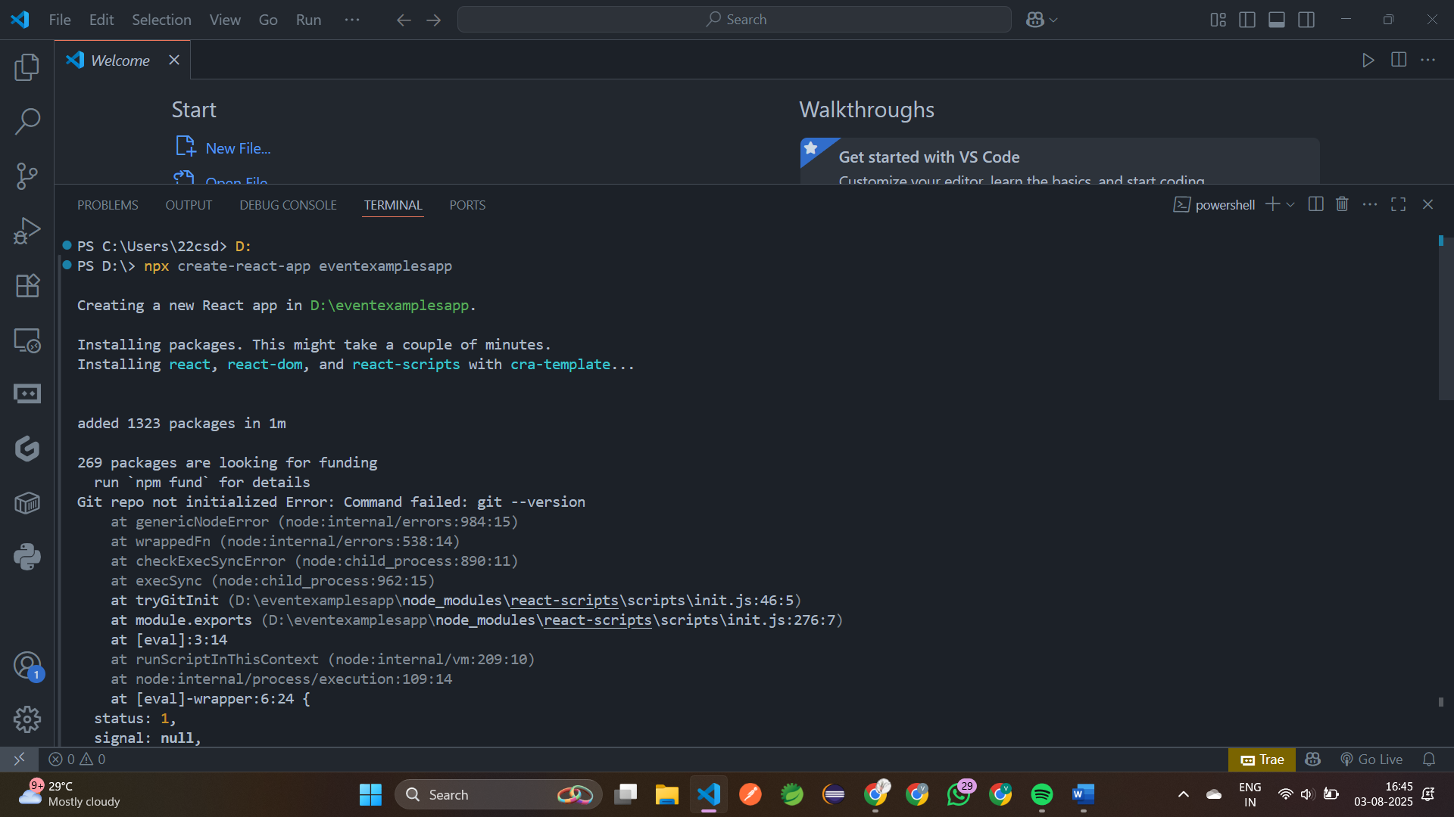

Step 4: Create a component **Counter.js**

import React, { useState } from 'react';  
 function Counter() {  
 const [count, setCount] = useState(0);  
 const increment = () => {  
 setCount(previous => previous + 1);  
 }; const sayHello = () => {  
 console.log('Hello!');  
 }; const handleIncrement = () => {  
 increment();  
 sayHello();   
 }; const decrement = () => {  
 setCount(previous => previous - 1);  
 }; return (  
 <div style={{ margin: '20px' }}>  
 <h2>Counter: {count}</h2>  
 <button onClick={handleIncrement}>Increment</button>{' '}  
 <button onClick={decrement}>Decrement</button>  
 </div> );}export default Counter;

Step 6: Create another component **welcome.js**

import React from 'react';  
 function welcome() {  
 const greet = (msg) => {  
 alert(msg);  
 };   
 return (  
 <div style={{ margin: '20px' }}>  
 <button onClick={() => greet("Welcome!")}>Say welcome</button>  
 </div>  
 );  
 }export default welcome;

step 7: Create a new file **Click.js:**

import React from 'react';  
 function Click() {  
 const handleClick = () => {  
 alert('I was clicked');  
 };  
 return (  
 <div style={{ margin: '20px' }}>  
 <button onClick={handleClick}>Click Me</button>  
 </div>  
 );

}export default Click;

Step 8: Create a new file **Currencyconvertor.js**

import React from 'react';  
import React, { useState } from 'react';  
function Currencyconvertor() {  
 const [rupees, setRupees] = useState('');  
 const [euro, setEuro] = useState(null);  
 const handleSubmit = () => {  
 const rate = 0.011;   
 const converted = (parseFloat(rupees) * rate).toFixed(2);  
 setEuro(converted);  
 };  
 return (  
 <div style={{ margin: '20px' }}>  
 <h2>Currency Convertor!!!</h2>  
 <input type="number" placeholder="Enter amount in INR" value={rupees} onChange={(e) => setRupees(e.target.value)} />  
 <button onClick={handleSubmit}>Convert</button>  
 {euro && <p>{rupees} INR = {euro} Euro</p>}  
 </div>  
 );}export default Currencyconvertor;

Step 9: Open **App.js** in src and modify it:

import React from 'react';  
 import Counter from './Counter';  
 import Click from './Click';  
 import Currencyconvertor from './Currencyconvertor';  
 import Welcome from './welcome';  
 function App() {  
   return (  
    <div className="App">  
      <Counter />    
    <Welcome />  
      <Click />  
      <Currencyconvertor />  
    </div>  );}  
export default App;

step 10: Run the App using **npm start**

Url: <http://localhost:3000>

